Table S1 Primers used in this study

Gene ID | Sense Primer | Anti-sense Primer | Product Size (bp)
ACT1 | TTGGTAGGCGGTGCAAGTAG | ACCTTCAACTTCGGCAGCAT | 135
gene4135 | ACTCGTGGTTCTCTGGCTTG | AGGAGCAGAAGTAGCTGGGA | 192
gene4006 | TACTGAGAGGGAGAACAAAGGGT | GCAGAAATGAGGTTGGCCCT | 117
gene1449 | CGATGAAGGCTGTCTGTCCA | CGCTAGTGCAGGGTTGACTT | 206
gene3386 | GCAACTGCCATCCTCAATGC | TGGGAACGACATGGTTGGAG | 225
gene1704 | TTTCATGGACCCTCCTGCAC | ATCTTCCGAGTGCCGTTAGC | 104
gene3874 | ACTCCATCTCCAACTCCCGA | TATCCCTCTTCAACGTGGCTG | 100
gene2404 | TTGATGGGTGCTTCAACGAGA | TCATCCCTTGCGACATGCTT | 166
gene1539 | ATCCTGCCTCATCCTTCCCT | AACGAAAAACAGCACGCCTC | 170
gene4366 | GAAGAAGTGAACAGCACCGC | TAACACTTGGGCATGCGACT | 110
gene2950 | TGGAGAGTAATTCAGACAACAGGA | GGCAGTGGCCATCTACACTT | 145

Table S2 Summary of sequencing results

Sample ID | Clean Reads | Clean bases | GC Content | %≥Q30
F01 | 24,727,029 | 7,386,359,186 | 41.59% | 95.54%
F02 | 21,375,956 | 6,388,695,398 | 41.61% | 95.35%
F03 | 23,034,026 | 6,882,830,610 | 41.33% | 95.03%
T01 | 22,039,793 | 6,587,586,484 | 41.60% | 95.26%
T02 | 21,813,621 | 6,512,066,430 | 41.44% | 95.40%
T03 | 21,391,199 | 6,389,445,418 | 41.44% | 95.41%

Table S2 Summary of mapping results
Sample ID | Total Reads | Mapped Reads | Unique Mapped Reads | Multiple Map Reads
F01 | 49,454,058 | 47,754,023 (96.56%) | 44,805,108 (90.60%) | 2,948,915 (5.96%)
F02 | 42,751,912 | 41,344,123 (96.71%) | 37,437,614 (87.57%) | 3,906,509 (9.14%)
F03 | 46,068,052 | 44,560,934 (96.73%) | 41,571,885 (90.24%) | 2,989,049 (6.49%)
T01 | 44,079,586 | 42,657,884 (96.77%) | 40,544,909 (91.98%) | 2,112,975 (4.79%)
T02 | 43,627,242 | 42,209,718 (96.75%) | 40,618,238 (93.10%) | 1,591,480 (3.65%)
T03 | 42,782,398 | 41,414,594 (96.80%) | 40,352,752 (94.32%) | 1,061,842 (2.48%)

Figure S1 Correlation analysis among sample groups.

Figure S2 Correlation between RNA-seq and qRT-PCR data. Ten DEGs were randomly selected, and their expression levels were detected by qRT-PCR. The reference line indicates the linear relationship between RNA-seq and qRT-PCR.

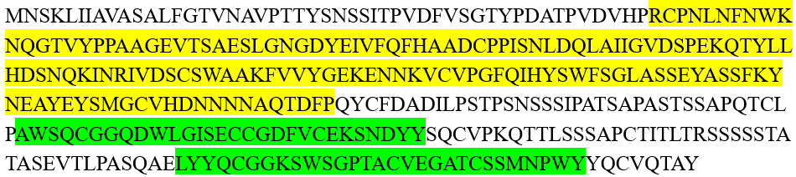

Figure S3 Analysis of the structural of the Flo11 domain-containing protein by using the online tool of Pfam. The yellow area represents Flo11 domain, while the green area fungal cellulose binding domains.

